Branch: MCA (Data Science) | Semester: 2
Student Name: Adarsh Mishra | UID: 25MCD10065
Subject Name: Technical Training - I | Subject Code: 25CAP-652
Section/Group: 25MCD – 1(A) | Date of Performance: 22 January,2026

Experiment No. : 2

- Aim/Overview of the practical:
To implement and analyze SQL SELECT queries using filtering, sorting, grouping, and aggregation concepts in PostgreSQL for efficient data retrieval and analytical reporting.
- Objective:
After completing this practical, the student will be able to:
• Retrieve specific data using filtering conditions
• Sort query results using single and multiple attributes
• Perform aggregation using grouping techniques
• Apply conditions on aggregated data using HAVING clause
• Understand real-world analytical queries commonly asked in placement interviews

- Software Used:
- PostgreSQL
- pgAdmin4

- Code for experiment/Practical:

CREATE TABLE customer_orders (
order_id INT PRIMARY KEY,
customer_name VARCHAR(50),
product VARCHAR(50),
quantity INT,
price NUMERIC(10,2),
order_date DATE
);

INSERT INTO customer_orders (order_id, customer_name, product, quantity, price, order_date) VALUES
(1001,'Amit', 'Laptop', 1, 55000, '2024-01-10'),
(2002,'Neha', 'Mobile', 2, 30000, '2024-01-12'),
(3003,'Ravi', 'Laptop', 1, 60000, '2024-01-15'),
(4004,'Priya', 'Tablet', 3, 45000, '2024-01-18'),
(5005,'Karan', 'Mobile', 1, 15000, '2024-01-20'),
(6006,'Anita', 'Laptop', 2, 110000, '2024-01-22');

SELECT *
FROM customer_orders
WHERE price > 40000;

SELECT customer_name, product, price
FROM customer_orders
ORDER BY price ASC;

SELECT customer_name, product, price
FROM customer_orders
ORDER BY price DESC;

SELECT customer_name, product, price
FROM customer_orders
ORDER BY product ASC, price DESC;

SELECT product, SUM(price) AS total_sales
FROM customer_orders
GROUP BY product;

SELECT product, SUM(price) AS total_sales
FROM customer_orders
GROUP BY product
HAVING SUM(price) > 70000;

- Result/Output/Writing Summary:
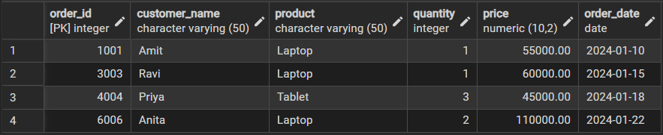
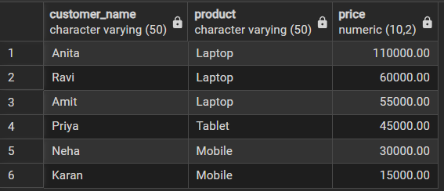
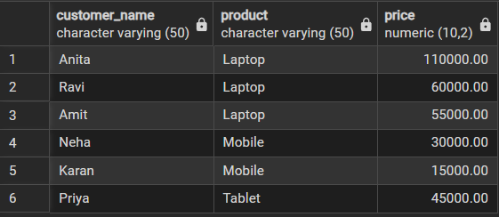

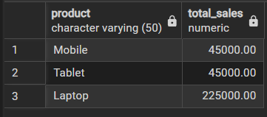

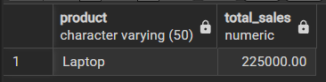

6. I/O Analysis (Input / Output)
Input:
• Customer order details
• Filtering, sorting, grouping, and aggregation queries

Output:
• Filtered customer records
• Sorted result sets
• Group-wise sales summary
• Aggregated revenue reports (Screenshots of execution and output attached)

Learning outcomes (What I have learnt):

• Students understand how data can be filtered to retrieve only relevant records.
• Students learn how sorting improves readability and usefulness of reports.
• Students gain the ability to group data for analytical purposes.
• Students clearly differentiate between WHERE and HAVING clauses.
• Students develop confidence in writing analytical SQL queries.
• Students are better prepared for SQL-based placement and interview questions.

